**Network Analysis Using Ping Tool**

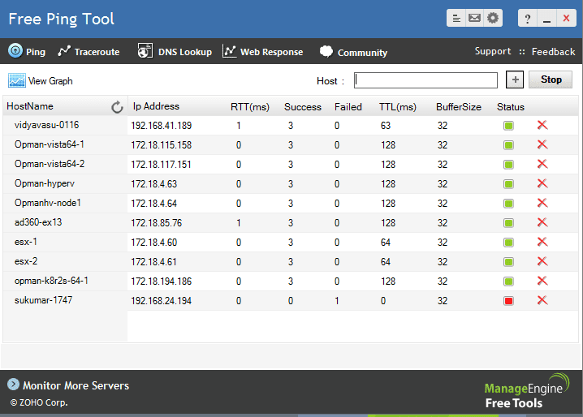

**Introduction**



Ping is a basic network diagnostic tool that tests the reachability of a host on an Internet Protocol (IP) network. It measures the round-trip time for messages sent from the originating host to a destination computer. This Capture the Flag (CTF) scenario introduces beginners to the basics of network analysis using the Ping tool available at HackerTarget.

Tools and Requirements

* HackerTarget Ping Tool: An online tool for testing network reachability.

Link: <https://hackertarget.com/test-ping/>

**Scenario**



In this scenario, you will use the HackerTarget Ping Tool to analyze the IP address of Google. Your tasks include understanding the response times, analyzing the number of hops, and interpreting the results to capture flags.

Begin

To start, familiarize yourself with the HackerTarget Ping Tool. Use this tool to ping the IP address of Google (8.8.8.8) and analyze the results to solve the challenges and capture the flags.

Questions

Flag 1: How many packets were sent in the ping test to 8.8.8.8?

Answer: 4 packets

Flag Captured.

Flag 2: What is the packet loss percentage in the ping test to 8.8.8.8?

Answer: 0%

Flag Captured.

**Hint**

